**DevOps Bash script to check Server Health**

**Server Health Check Script**

This script provides a quick overview of the server’s health by displaying important system metrics like hostname, uptime, CPU usage, memory usage, disk space, and top processes.

**Line-by-Line Breakdown:**

1. Shebang

**#!/bin/bash**

This tells the system to use the Bash shell to execute the script.

1. Print header

**echo “== Server Health Check ==”**

Displays a title to make the output clear

1. Display Hostname

**echo “Hostname: $(hostname)”**

hostname command prints the server’s name

**$(command)** runs a command inside echo

1. Show system Uptime

**echo “Uptime: $(uptime -p)”**

**uptime -p** shows how long the system has been running in human-readable format

1. Show CPU Usage

**echo “--- CPU Usage ---"**

**top -bn1 | grep “Cpu(s)”**

**top -bn1** runs the top command in batch mode once (**-b** = batch mode, **-n1** = 1 iternation)

**grep “Cpu(s)**” extracts the CPU usage line

Notes: this helps monitor **CPU load**

1. Show Memory Usage

**echo “--- Memory Usage ---”**

**free -h**

**free -h** shows available and used memory (**-h** makes it human-readable)

1. Show Disk Usage

**echo “--- Disk Usage ---”**

**df -h /**

**df -h /** shows disk space usage for the root directory ( **/** ) in human-readable format

1. Show Top 5 Memory-consuming processes

**echo “--- Top 5 Processes ---”**

**ps -eo pid, ppid, cmd, %mem, %cpu –sort=-%mem | head -6**

**ps -eo pid, ppid, cmd, %mem, %cpu**:

* **pid** – process ID
* **ppid** – parent process ID
* **cmd** – command running the process
* **%mem** – memory usage
* **%cpu** – CPU usage

**–sort=-%mem** – sorts by highest memory usage first

**Head -6** – shows top 5 processes (**head -6** instead of **head -5** because the first row is a header)

Example Input via vi:

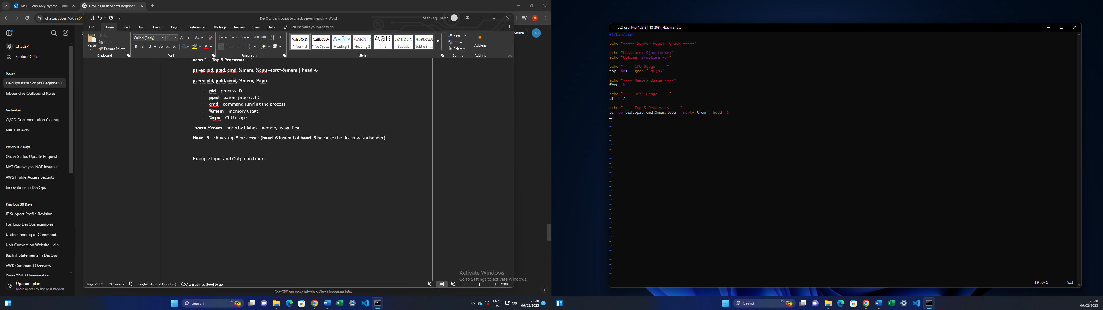

Make sure to change file permissions to execute the bash script.

Example output in Linux:

